**LEBANESE AMERICAN UNIVERSITY**

**USAID – HIGHER EDUCATION SCHOLARSHIP PROGRAM**

**HES - Volunteering Program Verification Form**

This form is to be used to document volunteering hours. If a student volunteers for multiple organizations, a separate form must be used for each organization. **This form must be turned in by the 28th of each month, the latest.**

I certify that the scholar Maher Alsayed completed a total of 5 hours of service at Life Sculptor.

The hours were completed hours as per the below:

Hours # 0 (date) _30/09 – 5/10_ (initials of supervisor) __A.K.___

Hours # 0 (date) _7/10 – 11/10_ (initials of supervisor) __A.K.___

Hours # 5 date) _14/10 – 18/10 (initials of supervisor) __A.K.___

Hours # 0 date) _21/10 -25/10 (initials of supervisor) __A.K.___

Brief description of the activities the scholar performed or participated in:

This mounth I volunteered at life sculptor NGO during my time as a volunteer at the NGO I was assigned several tasks such as preparing a power point presentation and researching about the topic of microfinance. My experience with life sculptor this mounth provided me with a better understanding of the field of microfinance and how it contributes to the reduction of poverty and financial inclusion.

Written feedback about the scholar’s performance:

Maher’s volunteer experience at Life Sculptor, particularly in researching microfinance, has enriched his understanding of poverty reduction strategies and financial inclusion, demonstrating his commitment to social impact initiatives.

Please rate the overall performance of the scholar at your organization:

|  |  |  |  |
| --- | --- | --- | --- |
|  | Mastery (5) | Proficient (3) | Emerging (1) |
| **Problem solver** | X |  |  |
| **Engaged & Committed** | X |  |  |
| **Open-minded & multicultural** | X |  |  |

Signature

& stamp

__________________________

_

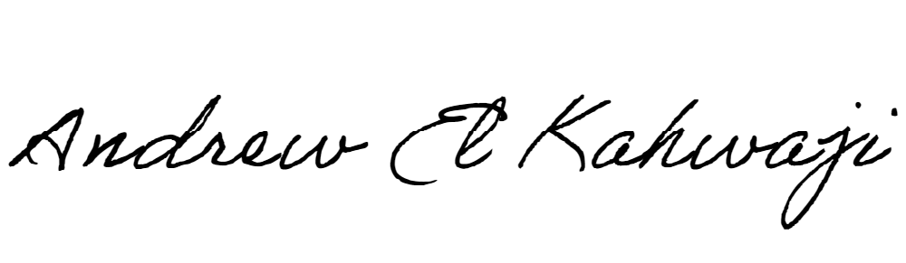

Printed Name _Andrew El Kahwaji_

Date __26/10/2024___

Email __andrew.lifesculptor.coo@gmail.com __

Phone __+961 71 914 378__

**LEBANESE AMERICAN UNIVERSITY**

**USAID – HIGHER EDUCATION SCHOLARSHIP PROGRAM**

